58MM THERMAL RECEIPT PRINTER
Programmer Manual

1. COMMANDS
1.1 Command Notation
[Name] The name of the command.
[Format] The code sequence.
[Range] Gives the allowable ranges for the arguments.
[Description] Describes the command’s function.
[Details] Describes the usage of the command in detail.
[Notes] Provides important information on setting and using the printer command, if necessary.
[Default] Gives the default values, if any, for the command parameters.
[Reference] Lists related commands.
[Example] Gives examples of how to use the command.

Hex indicates the hexadecimal equivalents.
Decimal indicates the decimal equivalents.
[ ]k indicates the contents of the [ ] should be repeated k times.

1.2 Explanation of Terms
(1) Receive buffer
The receive buffer is a buffer that stores, as is, the data received from the host (the reception
data). The reception data is stored in the receive buffer temporarily, and is then processed sequentially.
(2) Print buffer
The print buffer is a buffer that stores the image data to be printed.
(3) Print buffer full
This is the state where the print buffer is full. If new print data is input while the print buffer is
full, the data in the print buffer is printed out and a line feed is executed. This is the same
operation as the LF operation.
(4) Start of line
The start of line state satisfies the following condition:
• There is no print data (including spaces and portions of data skipped due to bit image data)
currently in the print buffer.
• There is no print data (including portions of data skipped due to HT)
• The print position is not specified by the ESC $ or ESC \ command.
(5) Printable area
The maximum range within which printing is possible under the printer specifications. The printable area for this printer is as follows:
① The length of the horizontal direction in standard mode:
approximately 72.1 mm {576/203"}
② The length of the horizontal direction in page mode:
approximately 72.1 mm {576/203"}
③ The length of the vertical direction in page mode: approximately 117.3 mm {1662/360"}
(6) Printing area
Printing range is set by the command. It must be printing area ≤ printable area.
(7) Ignore
The state in which all codes, including parameters, are read in and discarded, and nothing happens.
(8) Inch
A unit of length. One inch is 25.4 mm.
(9) MSB
Most Significant Bit
(10) LSB
Least Significant Bit
(11) Base line
Standard position when character data is stored in the print buffer.
Normal character in standard mode and page mode:

1.3. Control Commands

LF
[Name] Print and line feed
[Format] ASCII LF
Hex 0A
Decimal 10
[Description] Prints the data in the print buffer and feeds one line based on the current line
spacing.
This command sets the print position to the beginning of the line.

ESC SO
[Name] Set double width print for all characters
[Format] ASCII ESC SO
Hex 1BH OEH
Decimal 27 14
[Description] Characters after this command in the same line will be printed double width.
This command can be canceled by enter or ESC DC4 command.

ESC DC4
[Name] Cancel double width print for all characters
[Format] ASCII ESC DC4
Hex 1BH 14H
Decimal 27 20
[Description] Print the characters in normal width.

ESC ! n
[Name] Set print mode
[Format] ASCII ESC ! n
Hex 1B 21 n
Decimal 27 33 n
[Range] 0 ≤ n ≤ 255
[Description] Set characters print mode, to select to print characters times width and times height. Default n=0, characters normal size printing; n=16, characters times height printing; n=32, characters times width printing; n=48, characters times width and times height printing.

ESC % n
[Name] Select/cancel user-defined character set
[Format] ASCII ESC % n
Decimal 27 37 n
Hex 1B 25 n
[Range] 0 ≤ nL ≤ 255
[Description] • n is available only for the least significant bit.
• When the LSB of n is 0, the build-in character set is selected.
• When the LSB of n is 1, the user-defined character set is selected.

ESC & y c1 c2
[Name] Define user-defined characters
[Format] ASCII ESC & y c1 c2 [x1 d1...d(y×x1)]...[xk d1... d(y×xk)]
Hex 1B 26 y c1 c2 [x1 d1...d(y×x1)]...[xk d1... d(y×xk)]
Decimal 27 38 y c1 c2 [x1 d1...d(y×x1)]...[xk d1... d(y×xk)]
[Range] y = 3
32 ≤  c1 ≤ c2≤  126
0 ≤ x ≤ 12 Font A (9 x  9)
0 ≤  x≤  9 Font B(7 x  9)
0≤d1…d(y×xk)≤255
[Description] Defines user-defined characters.
• y specifies the number of bytes in the vertical direction.
• c1 specifies the beginning character code for the definition, and c2 specifies the final code. Only when c1=c2, up to 96 user-defined characters can be defined.
• x specifies the number of dots in the horizontal direction.
• d is the dot data for the characters. The data to define a user-defined character is (x×y) bytes and total is (c2-c1+1) characters.
• The defined user-defined characters will be valid till redefinition or reset or printer power off.
Example: using the standard ASCII code Font (12 x 24)
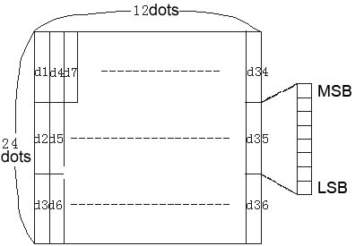
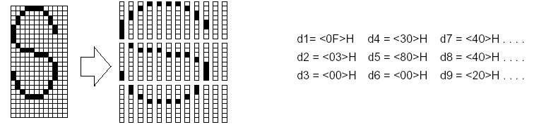

ESC * m nL nH d1 . . . dk
[Name] Select bit-image mode
[Format] ASCII ESC * m nL nH d1...dk
Hex 1B 2A m nL nH d1...dk
Decimal 27 42 m nL nH d1...dk
[Range] m = 0, 1, 32, 33;
1≤ (nL+nH x 256) ≤ 1023
0≤nL≤255;
0≤nH≤3;
0≤d≤255;
k=nL+ nH×256 (m=0, 1); k=(nL+ nH×256)×3 (m=32, 33)
[Description] • Selects a bit-image mode using m for the number of dots specified by nL and nH.
• The nL and nH indicate the number of dots of the bit image in the horizontal direction. The number of dots is calculated by nL + nH X 256.
• If the bit-image data input exceeds the number of dots to be printed on a line, the excess data is ignored.
• d indicates the bit-image data. Set a corresponding bit to 1 to print a dot or to 0 to not print a dot.
• Selects a bit-image mode using m for the number of dots specified by nL and nH, as follows:

m | Mode | Vertical Direction |  | Horizontal Direction
m | Mode | Dots | Density | Density | Data（k）
0 | 8-dot single-density | 8 | 67 DPI | 100 DPI | nL + nH × 256
1 | 8-dot double-density | 8 | 67 DPI | 200 DPI | nL + nH × 256
32 | 24-dot single-density | 24 | 200 DPI | 100 DPI | (nL + nH × 256)×3
33 | 24-dot double-density | 24 | 200 DPI | 200 DPI | (nL + nH × 256)×3
Example: 8-dot density selected
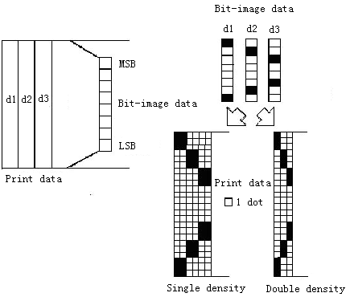
24-dot density selected
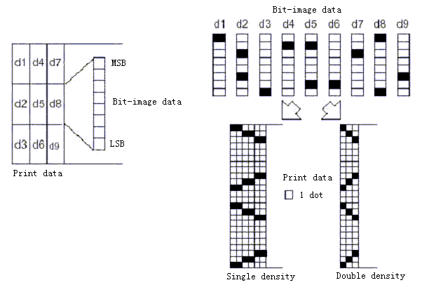

ESC 2
[Name] Select default line spacing
[Format] ASCII ESC 2
Hex 1B 32
Decimal 27 50
[Description] Selects 3.75mm line spacing.

ESC 3 n
[Name] Set line spacing
[Format] ASCII ESC 3 n
Hex 1B 33 n
Decimal 27 51 n
[Range] 0 ≤  n ≤  255
[Description] Sets the line spacing to n dots
[Default] n = 30

ESC ？ n
[Name] Cancel user-defined characters
[Format] ASCII ESC ? n
Hex 1B 3F n
Decimal 27 63 n
[Range] 32 ≤n ≤126
[Description] • This command cancels the pattern defined for the character code specified by n. After the user-defined characters are canceled, the corresponding pattern of the internal character is printed.
• If a user-defined character has not been defined for the specified character code, the printer ignores this command.

ESC @
[Name] Initialize printer
[Format] ASCII ESC @
Hex 1B 40
Decimal 27 64
[Description] Clears the data in the print buffer and resets the printer mode to the mode that is in effect when the power is turned on.

ESC J n
[Name] Print and feed paper
[Format] ASCII ESC J n
Hex 1B 4A n
Decimal 27 74 n
[Range] 0 ≤ n ≤ 255
[Description] • Print the data in the print buffer and feed the paper [n x  0.176mm (1/44inches)].
• The paper feed amount set by this command does not affect the values set by ESC 2 or ESC 3.

ESC c 5 n
[Name] Enable/disable panel buttons
[Format] ASCII ESC c 5 n
Hex 1B 63 35 n
Decimal 27 99 53 n
[Range] 0≤n≤255
[Description] Only the least significant bit of n is enabled.
• When the LSB of n is 0, the panel buttons are enabled.
• When the LSB of n is 1, the panel buttons are disabled.
[Default] n = 0

ESC d n
[Name] Print and feed n lines
[Format] ASCII ESC d n
Hex 1B 64 n
Decimal 27 100 n
[Range] 0≤n≤255
[Description] Prints the data in the print buffer and feeds n lines.

ESC p m t1 t2
[Name] Generate pulse for drawer
[Format] ASCII ESC p m t1 t2
Hex 1B 70 m t1 t2
Decimal 27 112 m t1 t2
[Range] m=0,1,48,49; 0≤t1≤255; 0≤t2≤255
[Description] This command is to generate pulse for controlling the cash drawer.
• The pulse ON time is [t1 x 2 ms] and the OFF time is [t2 x 2 ms].
• If t2 < t1, the OFF time is [t1x 2 ms].

ESC t n
[Name] Select character code table
[Format] ASCII ESC t n
Hex 1B 74 n
Decimal 27 116 n
[Range] 0 ≤n ≤ 10, 16 ≤n ≤ 19
[Description] Selects a page n from the character code table:
n | Page
0 | PC437 [U.S.A. & Europe Standard]
1 | Katakana
[Default] n = 0

GS * x y d1…dk
[Name] Define download bit image
[Format] ASCII GS * x y d1…dk
Hex 1D 2A x y d1…dk
Decimal 29 42 x y d1…dk
[Range] 1≤x≤48, 1≤y≤48, x×y≤1500, k=x×y×8
[Description] Defines download bit image.
• Only the least significant bit of n is enabled.
• d indicates the bit image data, that is, d=1 for printing the corresponding dot and d=0 for not printing the corresponding dot.
• There are (x×8) dots on horizontal direction and (y×8) dots on vertical direction.
• Once the download bit image has been defined, it is valid till executes redefine, printer reset or printer power-off.
• Relation between print data and download bit image:

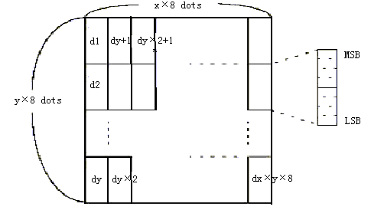

GS / m
[Name] Print downloaded bit image
[Format] ASCII GS / m
Hex 1D 2F m
Decimal 29 47 m
[Range] 0 ≤ m ≤ 3, 48 ≤ m ≤ 51
[Description] Prints downloaded bit image using the mode specified by m.
• m is for selecting bit image mode.
• GS * command can be use to define bit image.
• Selects bit image mode using m as follows:
m | Mode | Vertical Dot Density | Horizontal Dot Density
0, 48 | Normal | 200 DPI | 200 DPI
1, 49 | Double-width | 200 DPI | 100 DPI
2, 50 | Double-height | 100 DPI | 200 DPI
3, 51 | Double-width & Double-height | 100 DPI | 100 DPI

GS v 0 m xL xH yL yH d1....dk
[Name] Print raster bit image
[Format] ASCII GS v 0 m xL xH yL yH d1....dk
Hex 1D 76 30 m xL xH yL yH d1....dk
Decimal 29 118 48 m xL xH yL yH d1....dk
[Range] 0≤xL≤48, xH=0; 0≤yL≤255, yH=0; 0≤d≤255
k=(xL+xH×256)×(yL+yH×256)(k≠0)
[Description] Selects Raster bit-image mode. The value of m selects the mode, as follows:
m | MODE | Vertical Dot Density | Horizontal Dot ensity
0, 48 | Normal | 200 DPI | 200 DPI
1, 49 | Double-width | 200 DPI | 100 DPI
2, 50 | Double-height | 100 DPI | 200 DPI
3, 51 | Quadruple | 100 DPI | 100 DPI
• xL, xH, select the number of data bits ( xL+ xH × 256) in the horizontal direction for the bit image.
• yL, yH, select the number of data bits ( yL+ yH × 256) in the vertical direction for the bit image.
• This command has no effect in all print modes (character size, emphasized, double-strike, upside-down, underline, white/black reverse printing, etc.) for raster bit image.
• The part of bit image that exceeds the printable area will not be printed.
• d indicates the bit-image data. Set time a bit to 1 prints a dot and setting it to 0 does not print a dot.

FS &
[Name] Select Kanji character mode
[Format] ASCII FS &
Hex 1C 26
Decimal 28 38
[Description] Selects Kanji character mode.
The default print mode is Kanji character mode.

FS .
[Name] Cancel Kanji character mode
[Format] ASCII FS .
Hex 1C 2E
Decimal 28 46
[Description] Cancels Kanji character mode.
• Every character is processed as ASCII code and 1byte is processed every time.
• Kanji character mode is selected while printer is power on.

FS 2 c1 c2 d1…dk
[Name] Define user-defined Kanji characters
[Format] ASCII FS 2 c1 c2 d1…dk
Hex 1C 32 c1 c2 d1…dk
Decimal 28 50 c1 c2 d1…dk
[Range] c1=[FEH]、[A1H]≤c2≤[FEH]、k=72、0≤d≤255
[Description] • Defines user-defined Kanji characters for the character codes specified by c1 and c2.
• c1 and c2 indicate character codes for the defined characters. c1 specifies for the first byte, and c2 for the second byte.
• d indicates the dot data. Set a corresponding bit to 1 to print a dot or to 0 to not print a dot.
[Example]

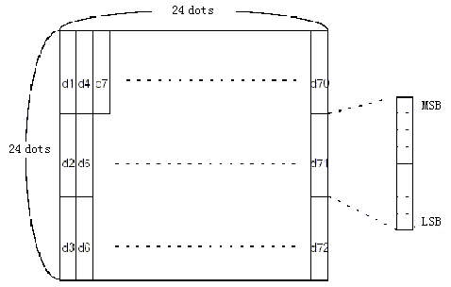
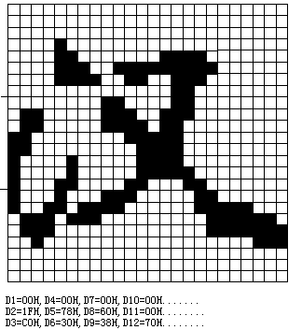

  - LED Digital Display Command

ESC @
[Name] Initial command
[Format] ASCII ESC @
Hex 1BH 40H
Decimal 027 064
[Description] Resume to the status of power on.

CLR
[Name] Clear display screen
[Format] ASCII CLR
Hex 0CH
Decimal 012
[Description] Clear all characters on the screen.

ESC Q A d1d2d3…dn CR
[Name] Send data to screen
[Format] ASCII ESC Q A d1d2d3…dn CR
Hex 1BH 51H 41H d1d2d3…dn 0DH
30H≤dn≤39H或dn=2DH或dn=2EH
Decimal 027 081 065 d1d2d3…dn 013
48≤dn≤57或dn=45或dn=46
[Description] • Data will be sent to the screen in overwrite mode by this command. By this method, it’s no need to use command CAN to clear the cursor line before sending data to the screen.
• If d1…dn is an integer, 1≤n≤8
• If d1…dn is a decimal, 1≤n≤15 (8 bits for integer & 7 bits for decimal)
• The data on screen can be clear by using command CLR or CAN.

ESC s n
[Name] Set "Unit Price" or "Total Price"
[Format] ASCII ESC s n
Hex 1BH 73H n
Decimal 027 115 n
[Range] 0≤n≤4
[Description] • When n=0, 3, 4, both “Unit Price” and “Total Price” dims;
• When n=1, “Unit Price” lights and “Total Price” dims;
• When n=2, “Unit Price” dims and “Total Price” lights.

CAN
[Name] Clear the cursor line
[Format] ASCII CAN
Hex 18H
Decimal 024
[Description] Clear all the characters on the line of cursor and the cursor moves to the first position. Commonly, use command ESC Q A d1d2d3…dn CR instead of this one.

ESC _ n
[Name] Set the cursor
[Format] ASCII ESC _ n
Hex 1BH 5FH n
Decimal 027 095 n
[Range] 0≤n≤1
[Description] This command is not commonly used.
• When n=0, the cursor dims;
• When n=1, the cursor lights.

ESC I x
[Name] Move the cursor
[Format] ASCII ESC I x
Hex 1BH 6CH x
Decimal 027 108 x
[Range] 0≤x≤8
[Description] This command is not commonly used. It’s used to move cursor to the position x.

